SISMID – within host modelling

2 – introduction to modelling

* Dynamic mechanistic modelling
  + In contrast to stats/epi modelling which are phenomenological models used to better understand your data – are there patterns? E.g. smoking and cancer.
    - Very useful but limited – can’t help us understand the mechanism causing this association
  + Mechanism = actually describe how infection happens etc.
* Why do it?
  + Understand the mechanism. Prediction – if you trust the model then can use model to create testable predictions (although tests can be v expensive)
* Within host modelling
  + Different to epi population level stuff – looking at spread inside a host and the population of cells and pathogens
  + Much more recent – only since late 80s
* The ‘systems’ of interest
  + Agents – e.g. pathogen. Immune components
  + Agent characteristic – e.g. lifespan of bacteria
  + Interactions – how agents interact with each other
* Simple example: fast replicating BACTERIA (discrete time)
 $B_{t+τ}=B_{t}+\left(gB_{t}-dB_{t}\right)τ$

 + Continuous time (ODEs)
  + $\frac{dB(t)}{dt}=gB\left(t\right)-dB(t)$ or $\dot{B}=gB\left(t\right)-dB(t)$
  + Computer still uses the first equation (in very small finite time steps) which approximates to the 2nd which we can do better maths with.
  + Possible end point dynamics – either infinite (if $g>d$) or 0 (if $d>g$)
* Extend: implement saturating growth (with logistic growth rate)
  + - as B gets very big then $gB$ becomes negative
    - if B very small then $gb(1)$ and back in exponential growth until B gets big again
* Extend: Introduce the immune response
  + $\dot{B}=gB\left(1-\frac{B}{k}\right)-dB-cIB$ where $c$ is a constant rate of bacteria death, proportional to the amount of immune response and bacteria in the system.
  + Now need to introduce the I compartment
  + $I=fB-hI$ generate immune response if there’s some bacteria and die off
  + OR $I=fBI-hI$ then growth of immune response depends on amount of immune response that already exists – e.g . T-cells dividing. So choice depends on biological context
  + Now have a version of the predator-prey model
* Extend: add a ‘dead cells’ compartment
  + $\dot{D}=dB+cIB$ if of interest to know how strong the immune response is
* Defining parameters
  + Get from the literature
* Need initial conditions too
  + Usually – init conditions less important than getting parameters right
* SIMPLE EXAMPLE – VIRUS
  + ‘mass-action’ interaction – when a parameter ‘bumps’ into uninfected and infected cells
  + Uninfected cells become infected at rate $b$. Infected cells die at rate $δ$. So the virus generates at $p$, clears at $c$ and enter infected cells at rate $b$
 $dU=-bUV$

 $dI=bUV-δI$

$dV=pI-cV-bUV$

+ ignore death rate of uninfected cells because lifespan of cells much longer than an acute infection (7 days or so)
  + N.B. can also *sometimes* ignore the $–bUV$ in $dV$ if it’s a lot smaller than the same term in $dU$. Two of the same negatives but one can dominate
  + N.B.2 – might need to add a parameter depending on units since viral load isn’t usually measured in particles so need to introduce $γ$ parameter to scale things accordingly
  + 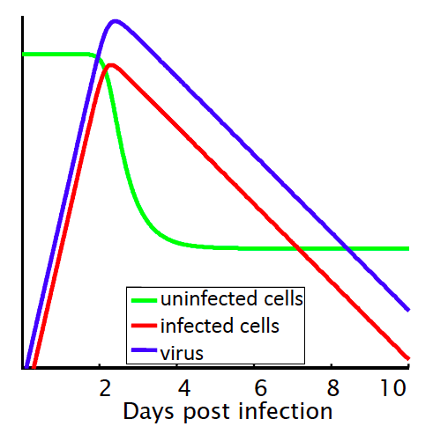standard presentation of viral load of acute infection e.g. flu

3 – Hepatitis C virus – Immunology

* Background
  + Positive RNA strand flavivirus
  + Reproduces very quickly - ${10}^{12}$ per day
  + Treatments first emerged in early 1990s
  + Uses envelope protein to find receptor on cell’s surface. Uncoats and replicates with negative RNA. Some complicated shit happens then it leaves the cell off to recreate somewhere else (possible that it passes cell-to-cell as well)
  + Receptors are very specific for HCV – so animal models in mice etc. don’t work great because very specific to humans
  + Infects the liver and is upstream of a lot of liver cancers. Causes damage and the liver tries to plug the gaps – causes legions and malformed cells
* What is the best immune response?
  + Small fast replicating virus – need antibodies but once it’s in the cells need killer T8 cells as well.
  + Innate immunity – can have a robust response but
  + Antibody-mediated response – there can be a correlation between high levels of antibody and HCV clearance. But high antibody level can also maintain chronic infection so neutralising ABs are not sterilising
  + Cell mediated clearance – kill infected cells
* Successful HCV response
  + 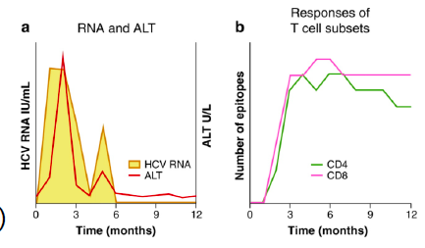
  + T cells go up quickly and are sustained (small drop off in t4)
  + 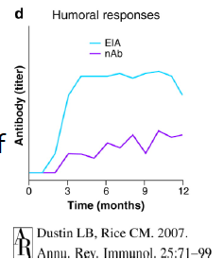
  + Lots of antibodies (ELISA – EIA line) but not many of them are neutralising!
* Unsuccessful response
  + 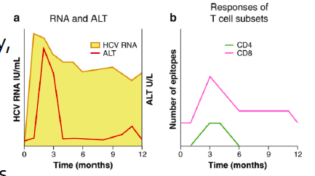
  + Genera ting a really robust viral AB response but clearly doing nothing to control the viral load:
  + 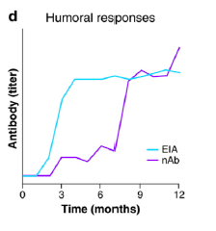
* The important thing is to produce interferon-induced genes
* TREATMENT
  + Type 1 interferon:
    - First therapy for HCV – presumably enhances the nrmal interferon pathways
  + Ribavirin
    - Originally a flu drug.
    - Gave up listening. V tired

L4 – Modelling HCV and HIV

* Modelling a **persistent** infection
  + Previously infection dies out with depletion of uninfected cells
  + So need to generate some new cells.
 $dU=λ-dU-bUV$

 $dI=bUV-δI$

$dV=pI-cV$

+ So now we want to include generation of uninfected cells $λ$. Also want to check that without any infection this works – i.e. when $V=0$
  + Allows for multiple outbreaks
  + For the equilibrium state: (ODEs $=0$)
    - Can solve for $dU, dI$ and $dV$
    - Now have three equations equal to 0 and can solve (not with R – can’t do algebra, but with a program called MAXIMA – see slides for code)
  + Once number of ODEs >3 then solution becomes so complicated it is relatively useless
* Modelling treatment:
  + Assume host is at steady state so start at equilibrium solution
  + 2 solutions for interferon mechanism to work:
    - add $\left(1-f\right)$ to scale infection of cells (before $bUV$)
    - OR add $(1-e)$ to creation of virus in $dV$ i.e. cells still get infected but don’t produce more virus
    - Now we test against data, turning $f$ and $e$ on/off and see how the model replicates the data
      * SEE LAB - SISMID-U4-hcv1
        + Only if $e$ is involved can you get the biphasic decline (initial fast drop followed by slow decline)
  + But efficacy of drug is not constant over time but decays
    - So let it decay and then red-dose of the drug at certain intervals
    - OR combine with another drug – ribavirin – see code v3
  + Further extension – some patients show triphasic decline (fast, slow, fast)
    - Done by including a homeostatic feedback loop